- Create a tomcat container on 8080 and deploy sample application in tomcat.
Objective :
To create a Tomcat container running on port 8080 and deploy a sample application in Tomcat.
Step by step implementation
Launch server and start the docker service
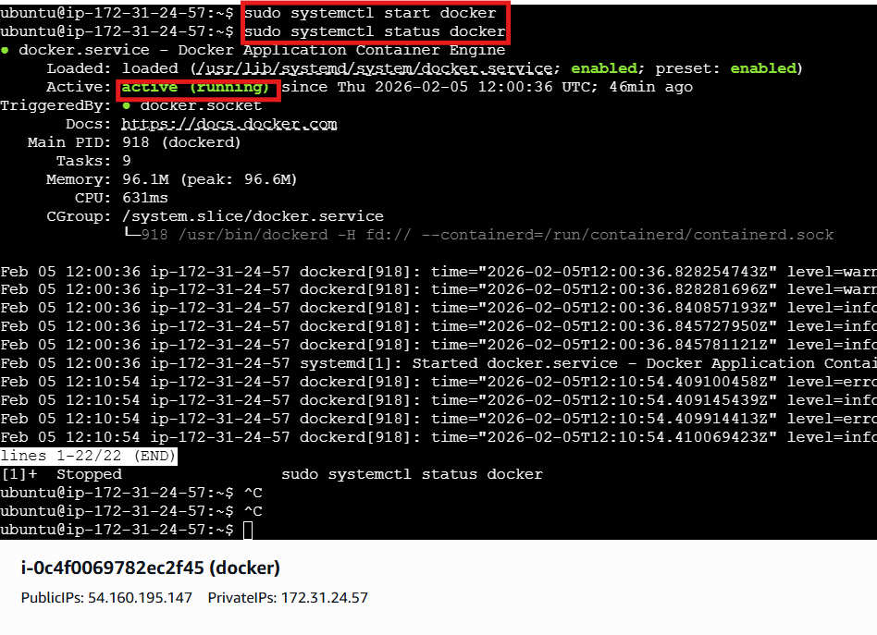

Change to root and view the docker images if tomcat is not present then pull the tomcat
And reverify in images
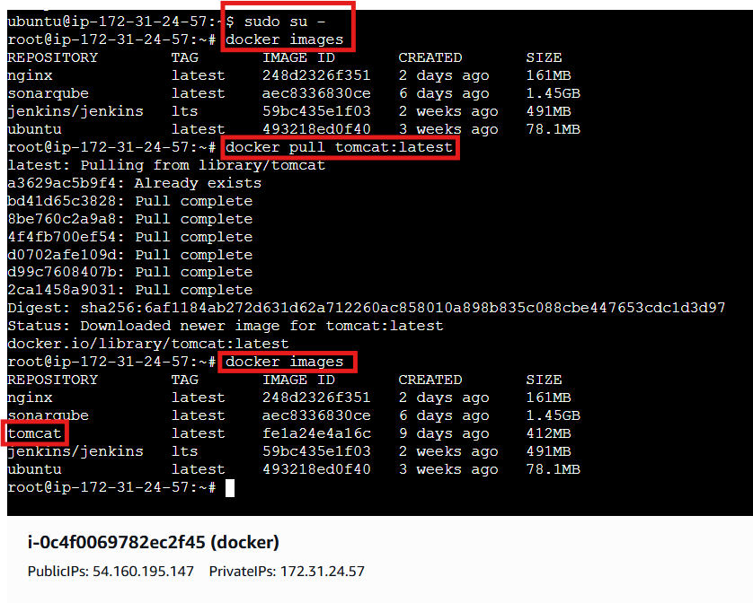
Run the container with port number 8080 in background
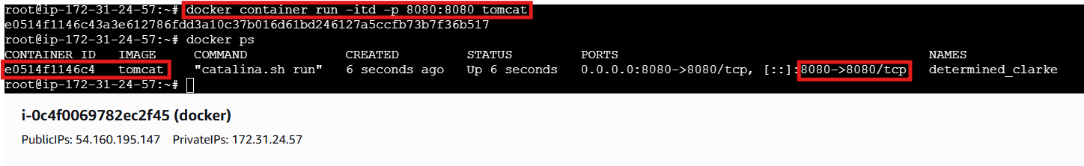
Verify in browser using publicip@portnumber
Here we got an error like 404 not found it because there is no sample file available for deployment
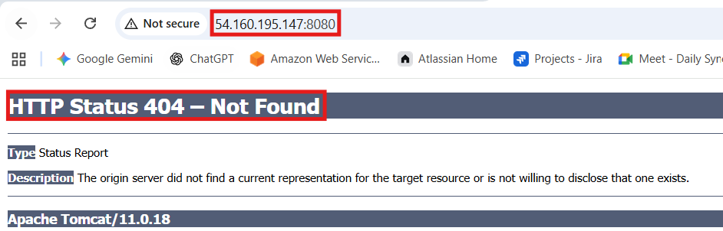
Then search for a sample file and copy the link
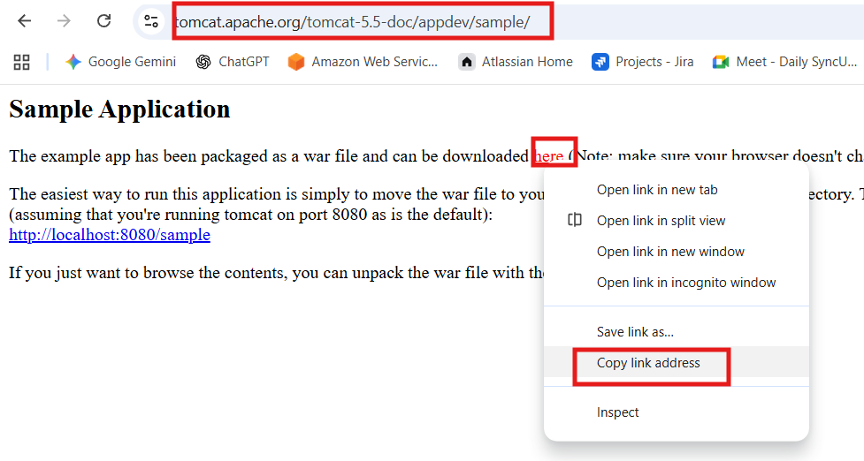
Get inside of tomcat container and perform the actions
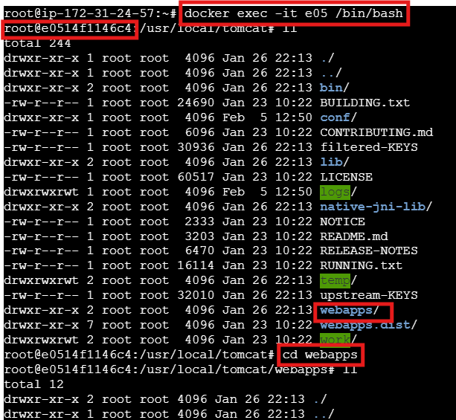

If you face any error regarding command not found then install the command like wget
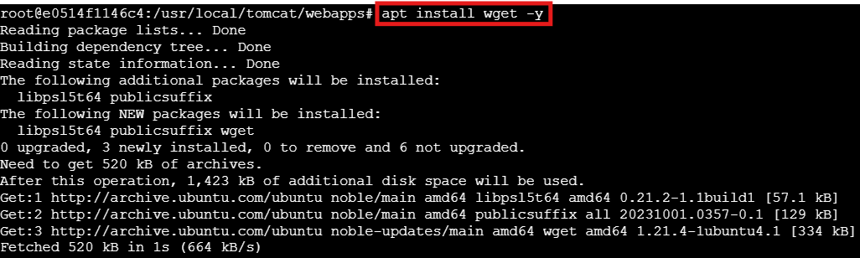
Then download the sample.war file and wait for few seconds to unzip the file it automatically does
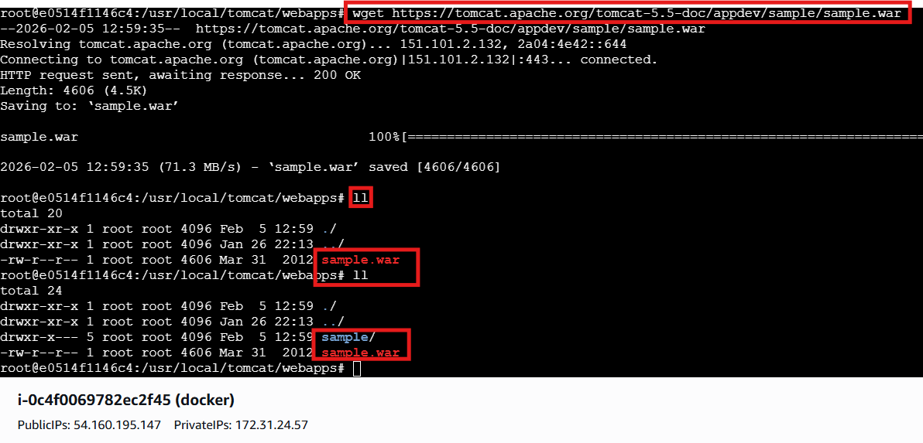
Later verify on web using /sample
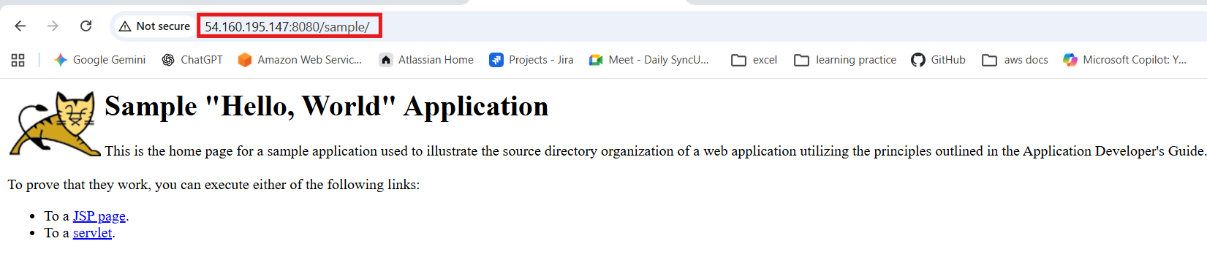
Conclusion :
A Tomcat container was successfully created on port 8080, and a sample application was deployed and verified, confirming that the Tomcat server is running and serving applications correctly.

- Create volume and deploy tomcat container on port 8081.
Objective :
To create a Docker volume for persistent storage and deploy a Tomcat container on port 8081 using that volume.
Bonus:
If u need to customize or change the name of image then you can use the below command
Step by Step Implementation:
Create a volume naming as prod
And verify the volumes using ls command
Get into the dir using default path of volumes and get inside of it
Inside of _data dir download the sample.war file
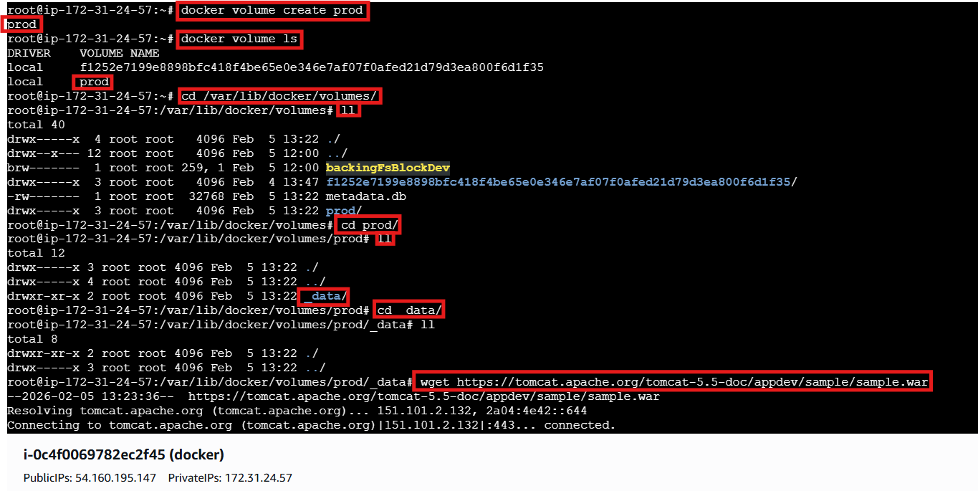

And verify using ll
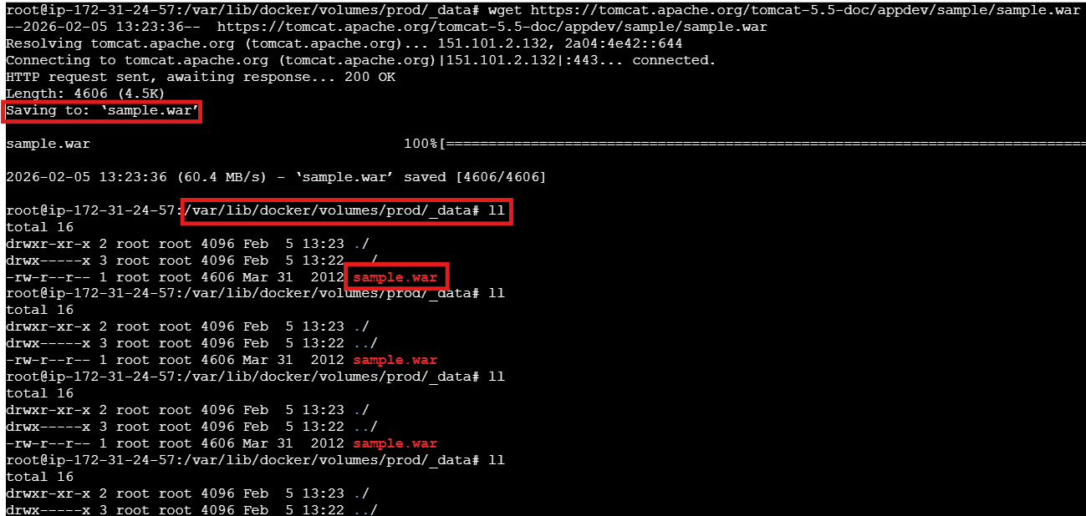
Now run the command by providing full path and verify on browser
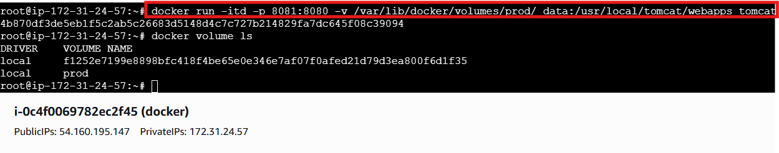
It worked
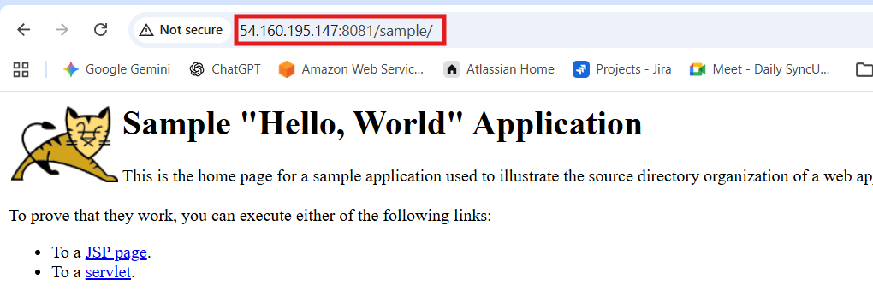
Conclusion:
A Docker volume was created to provide persistent storage, and a Tomcat container was deployed using that volume and exposed on port 8081. This ensures that application data inside Tomcat remains intact even if the container is stopped or recreated.

- Limit the nginx container to 500 MB.
Objective :
To run an Nginx container with its memory usage limited to 500 MB.
Step by Step Implementation
Use the command to start the container with memory limit
Docker container run -itd -p 82:80 –memory 500m nginx
Using the docker ps verify the container id and check the space
Use the command docker stats to check the memory
Conclusion :
The Nginx container was successfully deployed with a 500 MB memory limit, ensuring controlled resource usage and preventing excessive memory consumption.

- Create a sample docker file using below instructions.
- Base module as amazonlinux:latest
- Maintainer you name
- Install nginx
- COPY one index.html file to image
- Expose on port 80
- Command to start the nginx container
Objective:
To create a Docker image using amazonlinux:latest, install Nginx, copy a sample index.html file, and configure the container to run Nginx on port 80.
Implementation:
Step 1: Create index.html
Step 2: create Dockerfile and insert the data
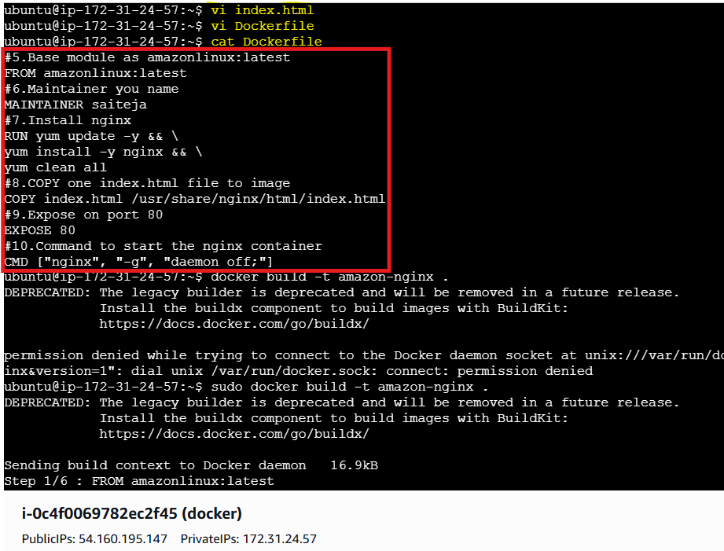

Syntax::
#5.Base module as amazonlinux:latest
FROM amazonlinux:latest
#6.Maintainer you name
MAINTAINER saiteja
#7.Install nginx
RUN yum update -y && \
yum install -y nginx && \
yum clean all
#8.COPY one index.html file to image
COPY index.html /usr/share/nginx/html/index.html
#9.Expose on port 80
EXPOSE 80
#10.Command to start the nginx container
CMD ["nginx", "-g", "daemon off;"]
After that execute the command docker build -ty amazon-nginx and it will download
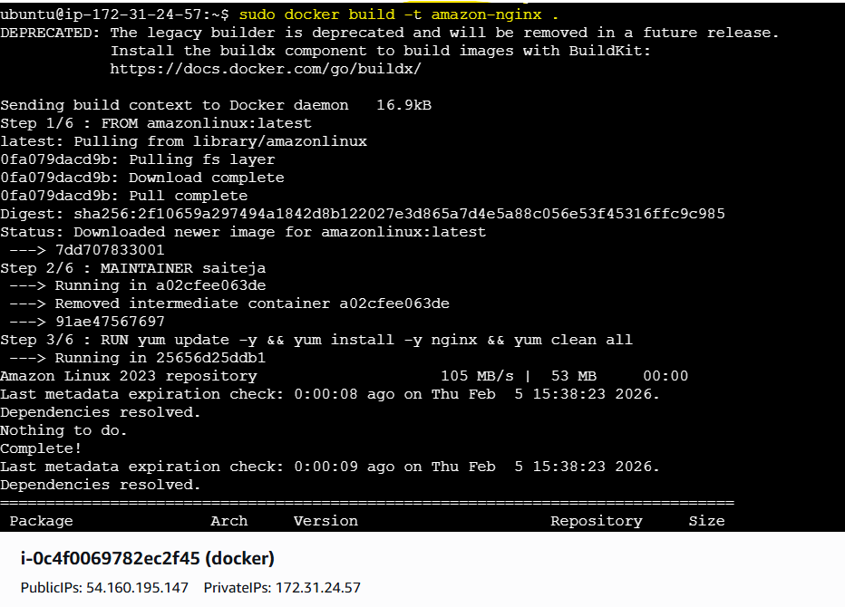
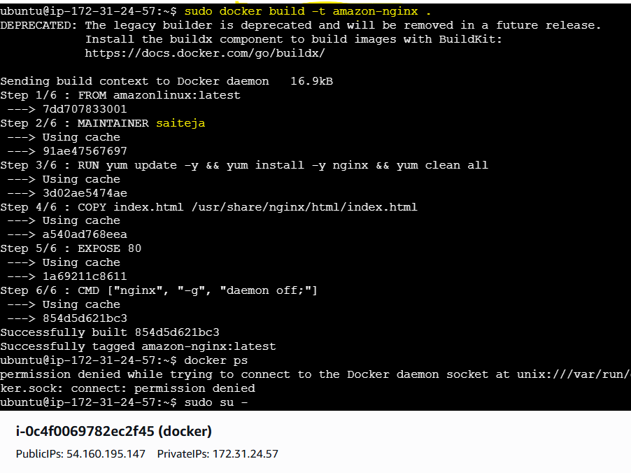
Running again nginx on port 83 and verified in browser
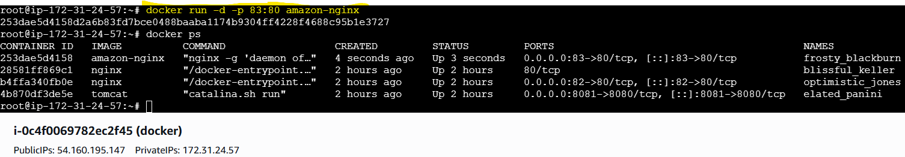
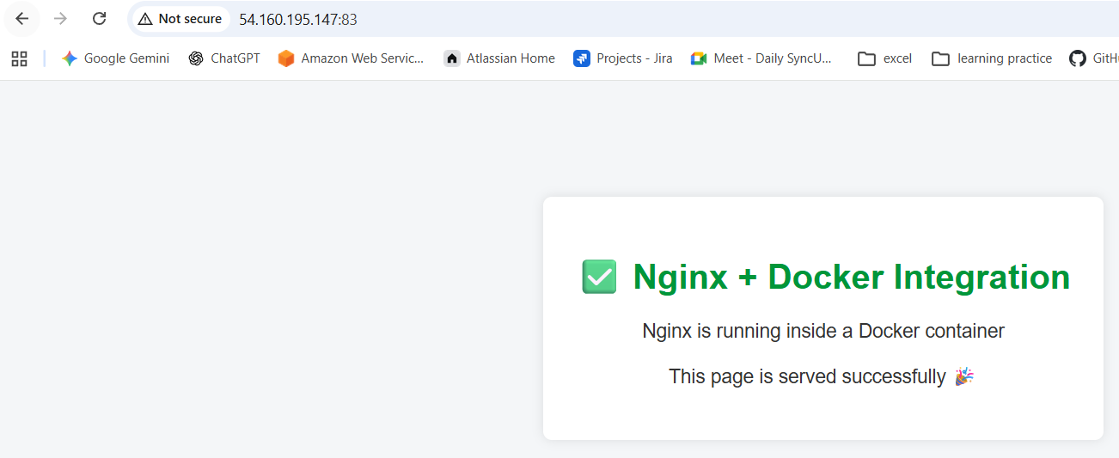
Conclusion:
A custom Docker image was successfully built with Amazon Linux and Nginx, serving a static index.html page on port 83, demonstrating basic Dockerfile creation and containerized web hosting.

- Push image to Docker hub
Objective :
To tag and push a Docker image to Docker Hub for storage and reuse.
Step By Step Implementation:
Login to docker hub in browser and create a account
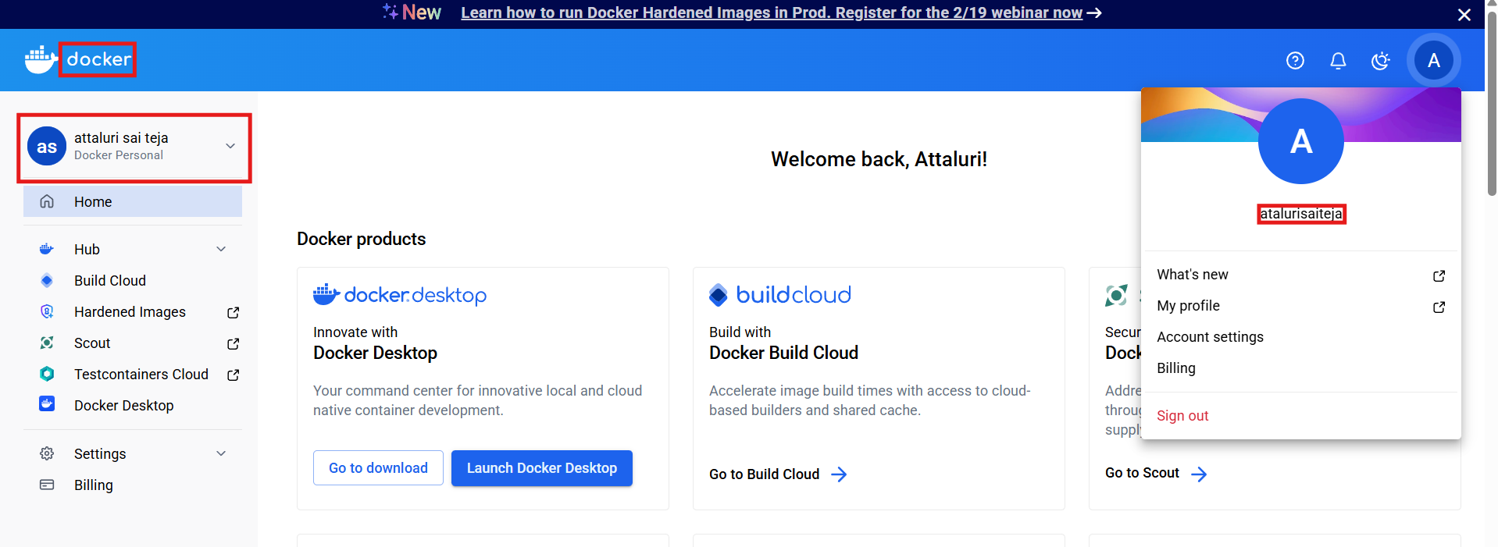
After that create a custom repository
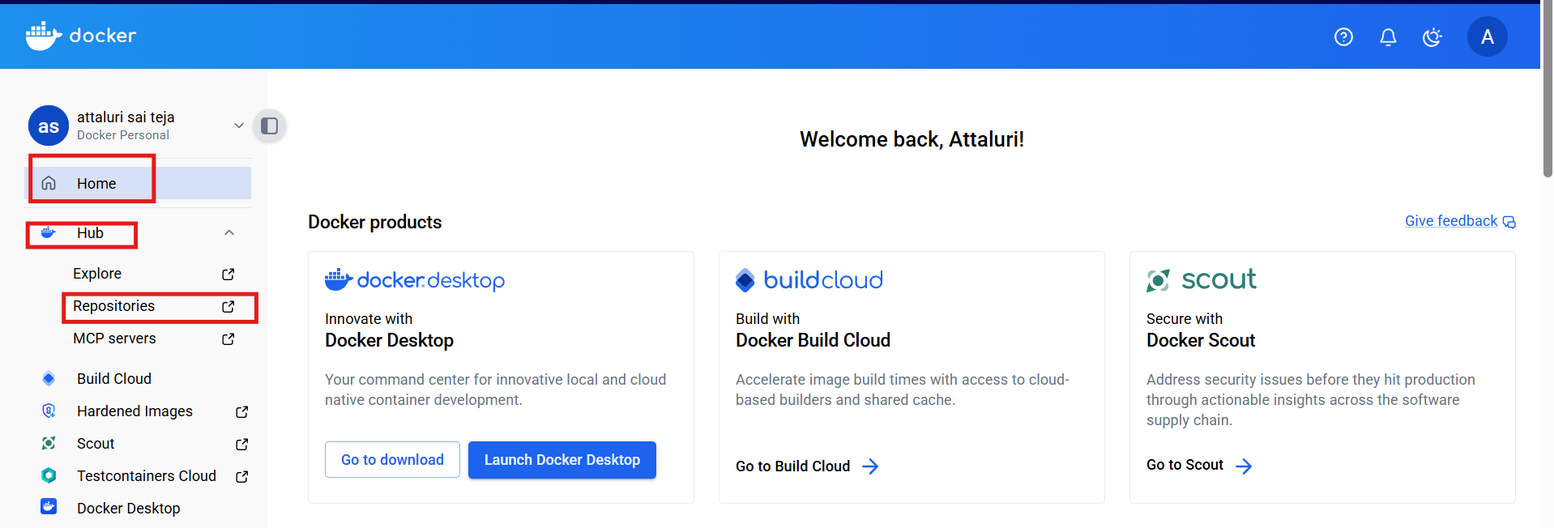
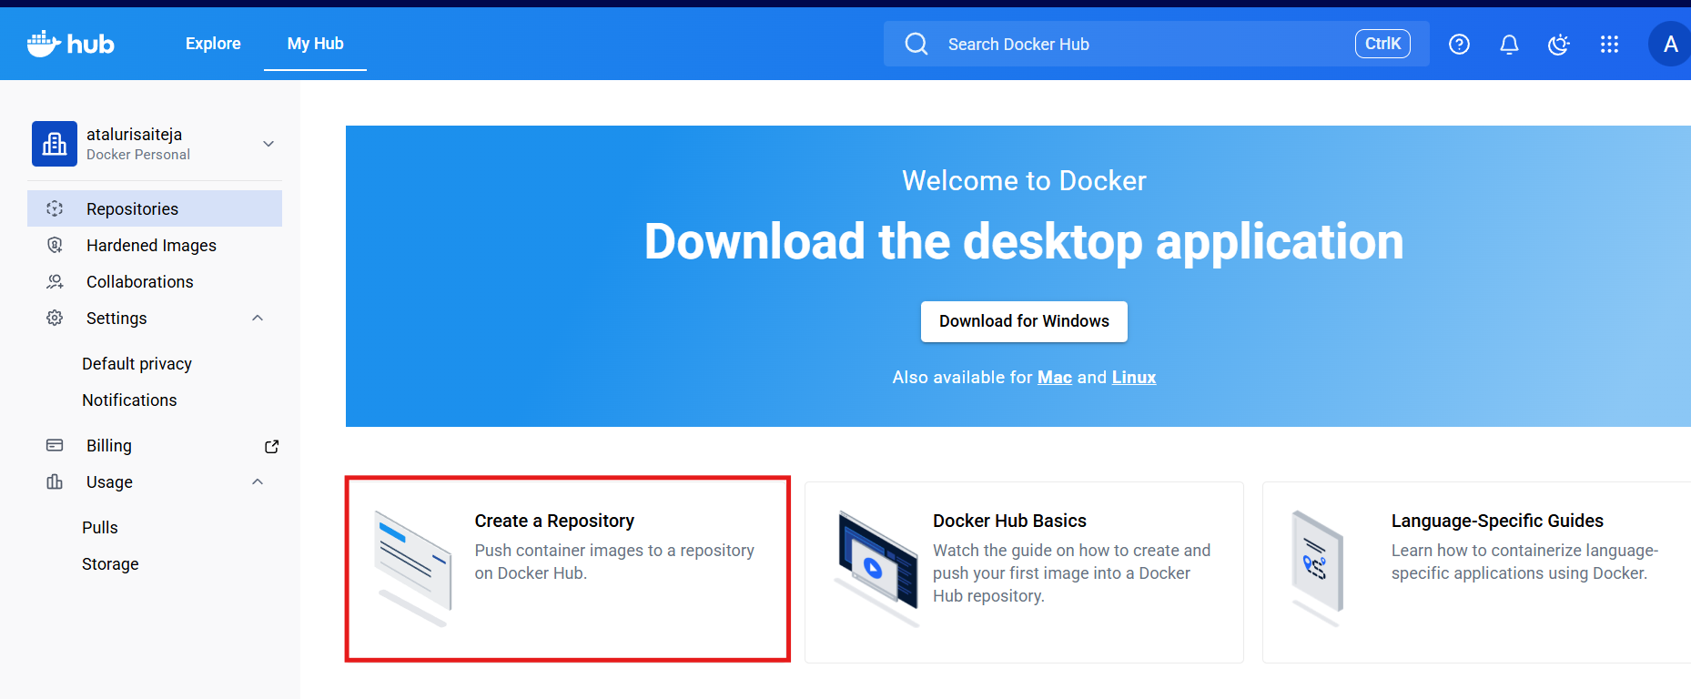
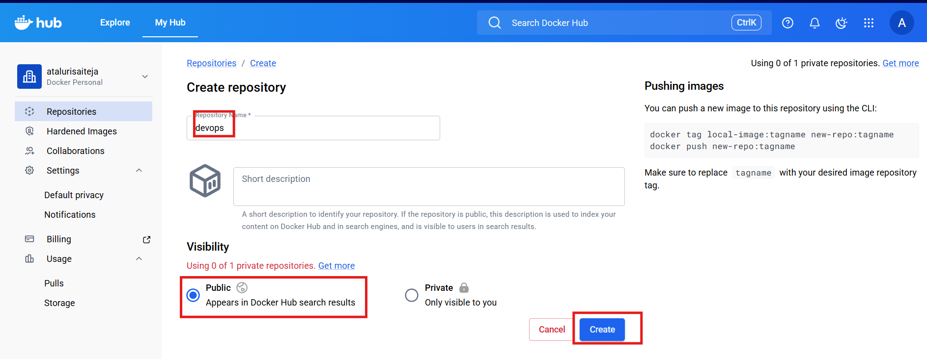
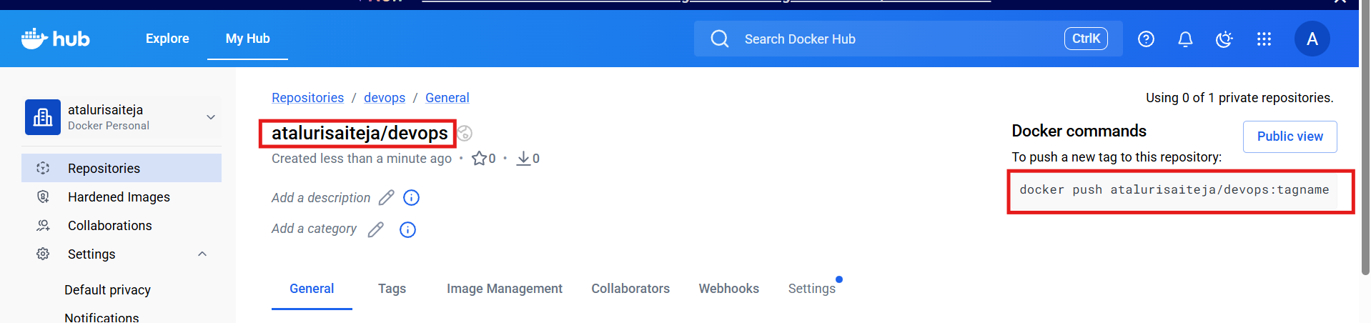
After that perform docker login in server for integrating
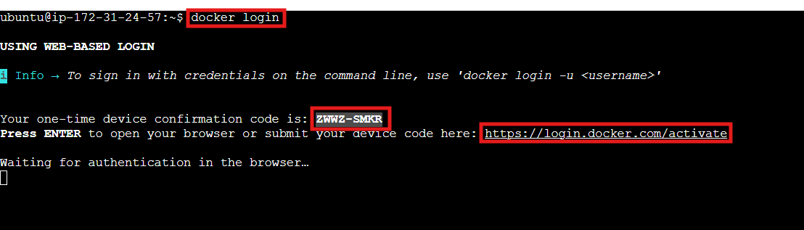
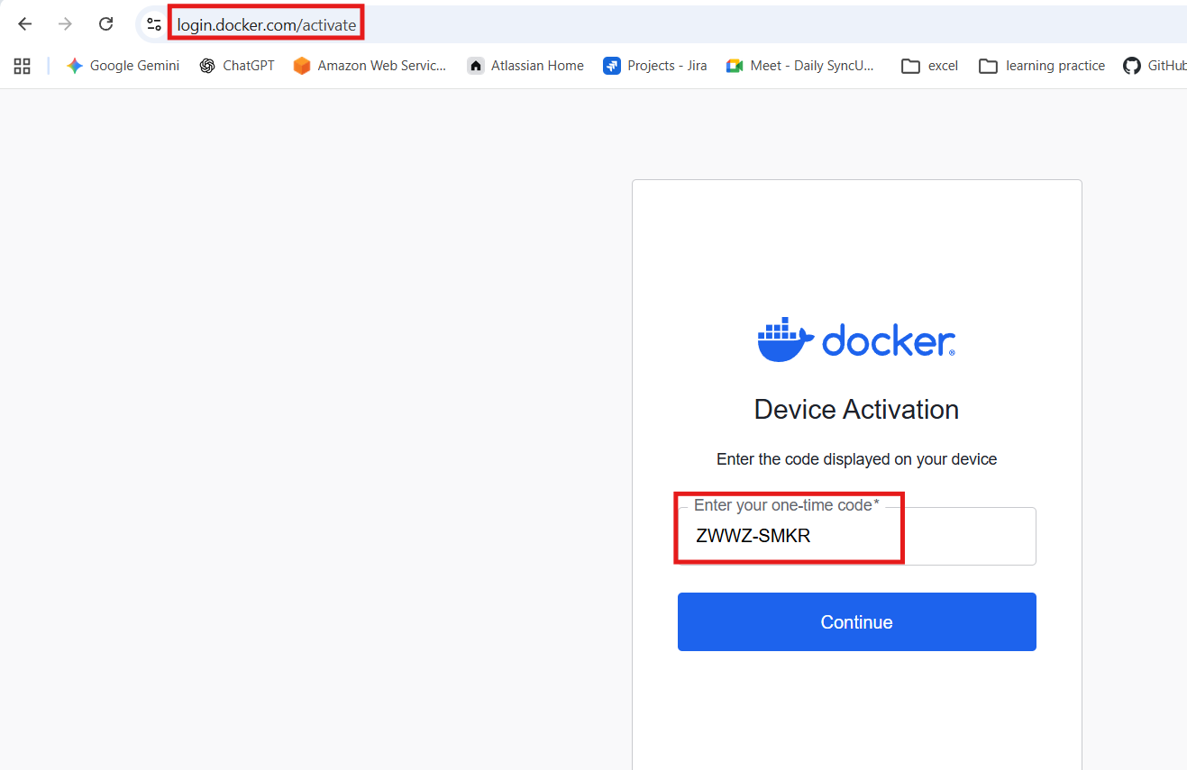
Login through root
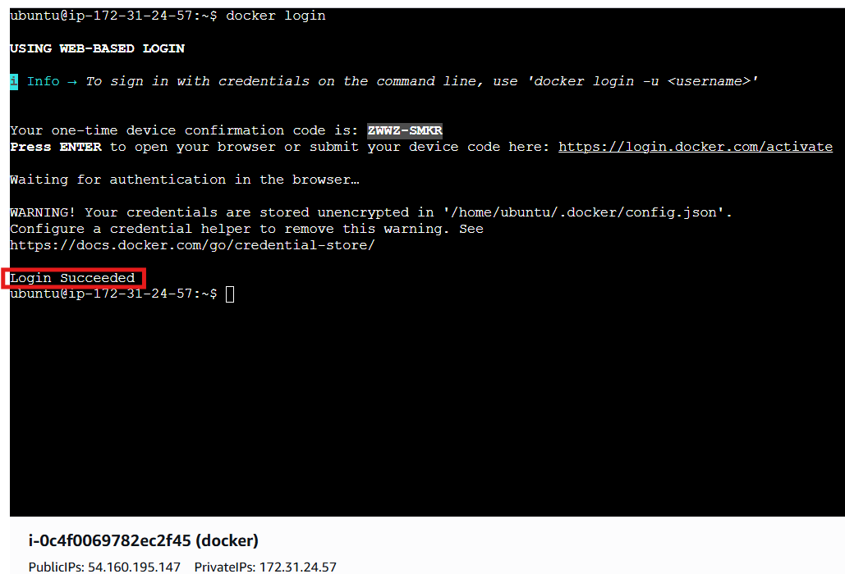
Tag the image
docker tag amazon-nginx atalurisaiteja/amazon-nginx:latest
Docker ps
Then docker push
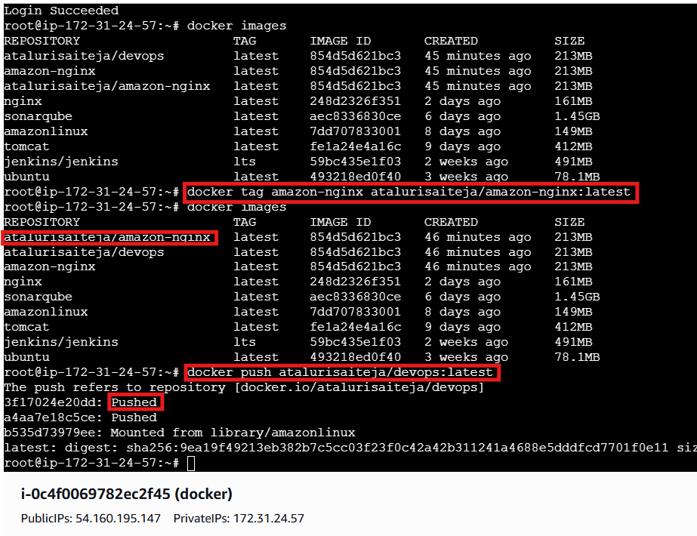
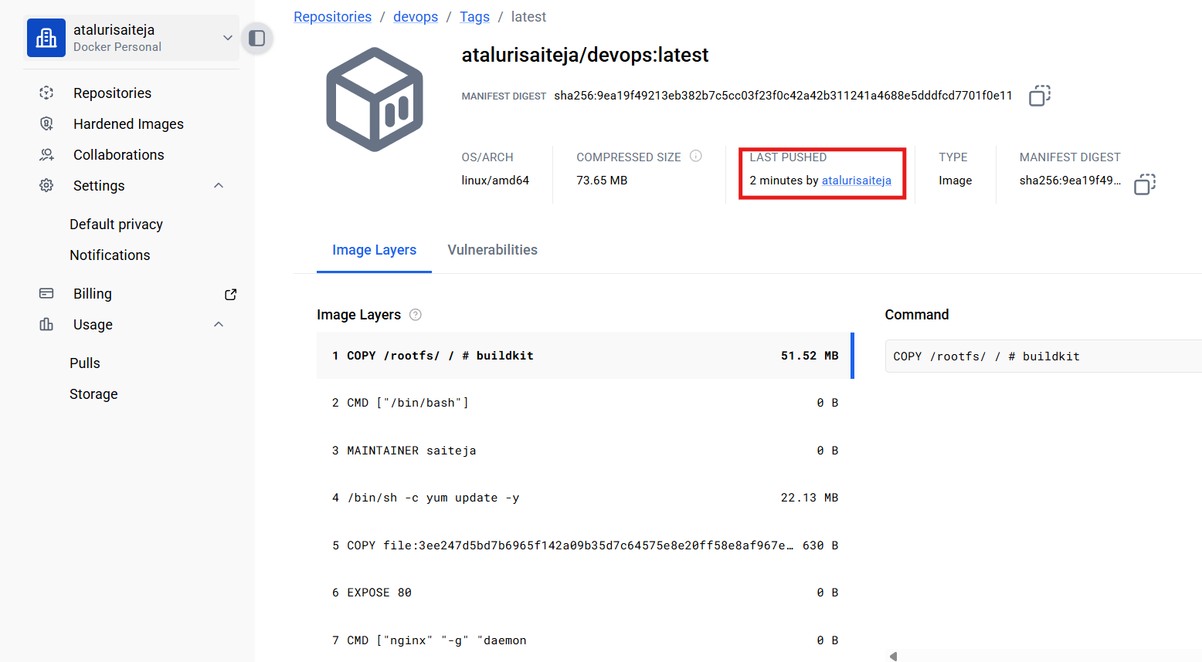
Conclusion :
The Docker image was successfully pushed to Docker Hub, making it available for sharing, deployment, and reuse across different environments.

- push image to AWS ECR
Objective :
To push a Docker image to AWS ECR (Elastic Container Registry) for secure storage and use within AWS services.
Step by Step Implementation:
Navigate to ecr and create a repository
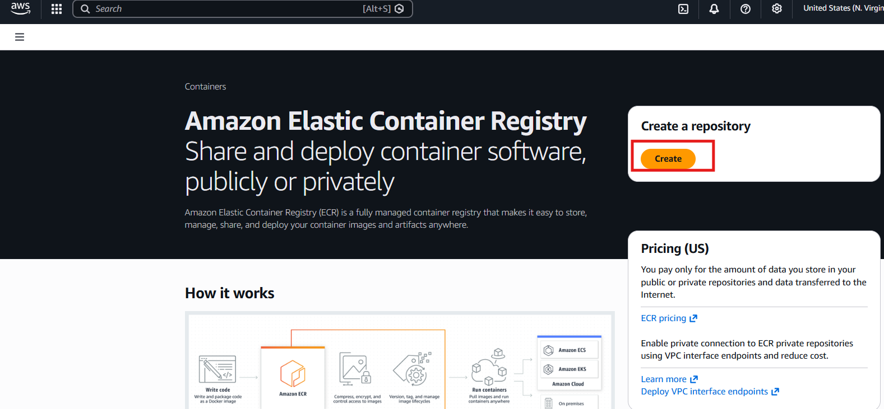
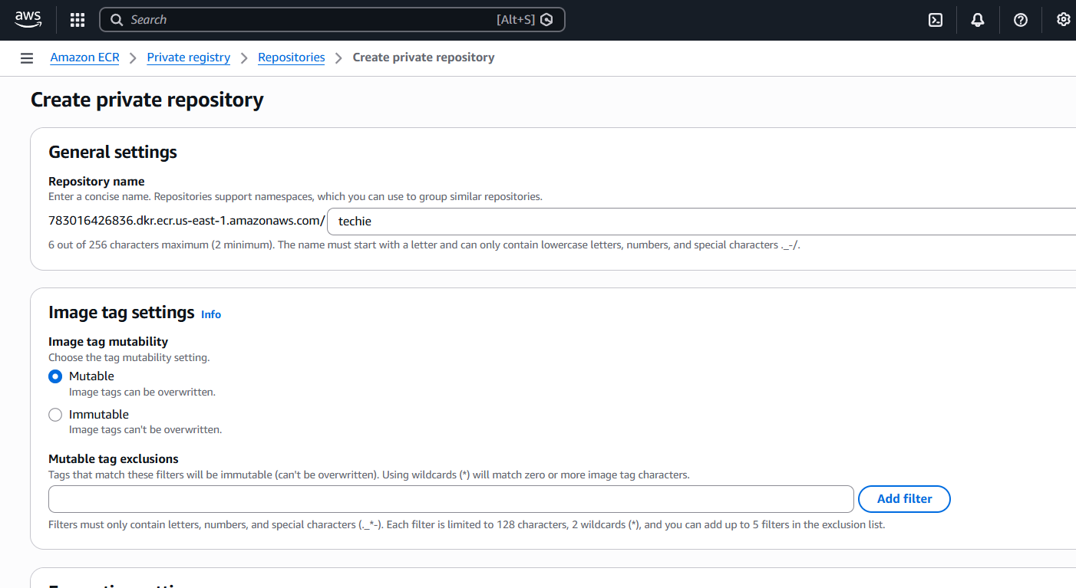
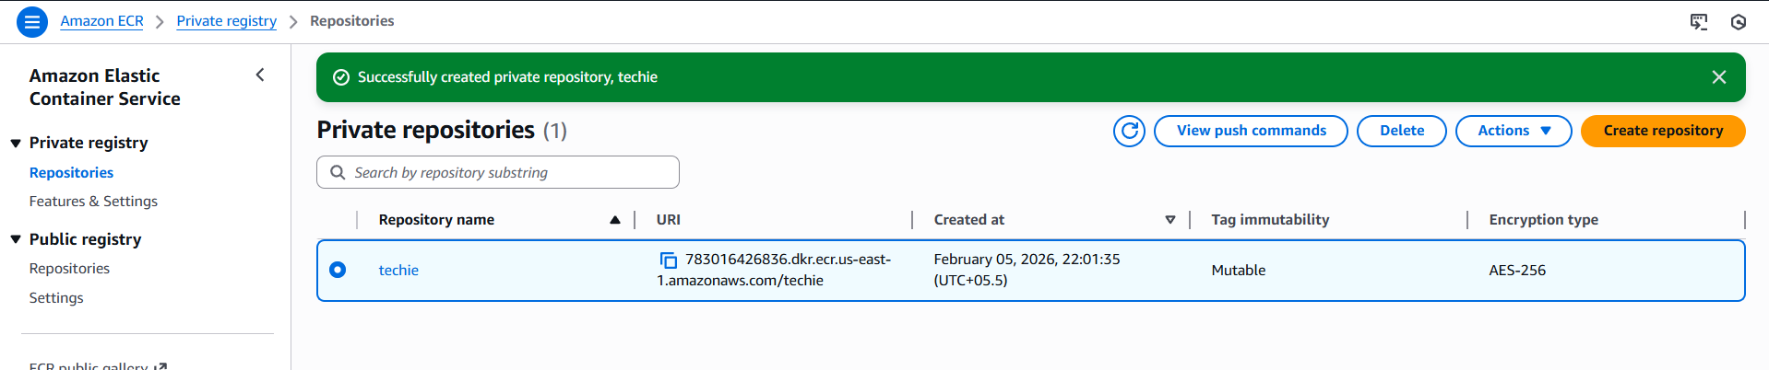
Perform aws configure
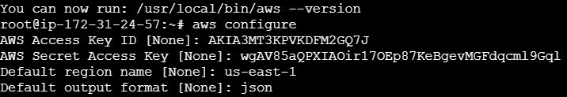
Authenticate Docker to AWS ECR
aws ecr get-login-password --region us-east-1 \
| docker login --username AWS --password-stdin 783016426836.dkr.ecr.us-east-1.amazonaws.com
Tag your image for ECR
docker tag amazon-nginx:latest 783016426836.dkr.ecr.us-east-1.amazonaws.com/devops:latest
Push image to AWS ECR
docker push 783016426836.dkr.ecr.us-east-1.amazonaws.com/devops:latest
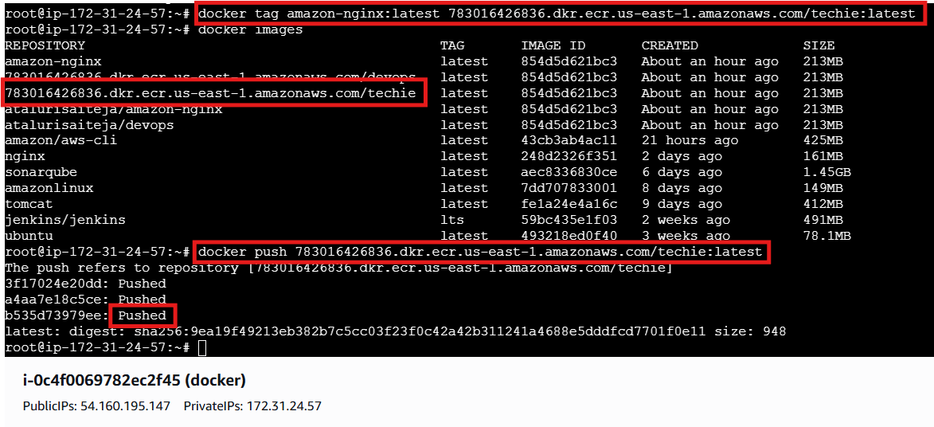

Verify
aws ecr list-images --repository-name devops --region us-east-1
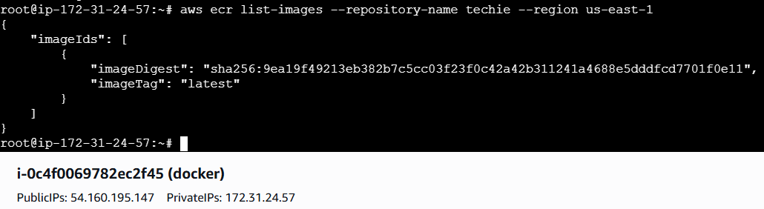
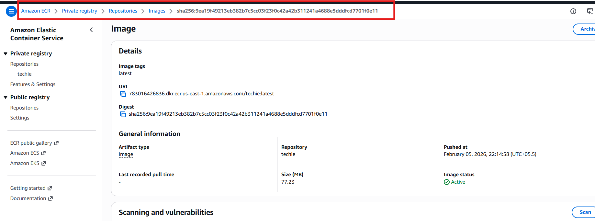
Steps to install aws cli:::
Update packages
sudo apt update
Install required packages
sudo apt install -y curl unzip
Download AWS CLI
curl "https://awscli.amazonaws.com/awscli-exe-linux-x86_64.zip" -o "awscliv2.zip
Unzip installer
unzip awscliv2.zip
Insall AWS CLI
sudo ./aws/install

Conclusion :
The Docker image was successfully pushed to AWS ECR, enabling centralized image management and seamless integration with AWS-based deployments such as ECS, EKS, or EC2.

